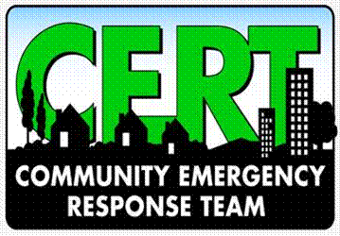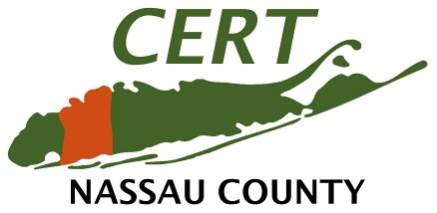

EVALUATION FORM

NAME (optional): ______________________________________________

LOCATION: ___________________________________________________

CLASS DATE: ______________________________________________

COURSE INSTRUCTOR(S):
PLEASE PRINT THE NAMES OF YOUR INSTRUCTOR(S):

_____________________________ ________________________________

Part 1. This information will be used to assess the effectiveness of this course and to improve course content.

On a scale of 1 to 5 with “5” being the highest, please mark the response which best reflects your opinion.

Course:

Strongly Disagree

Strongly Agree

1 2 3 4 5
COMMENTS: -If column “1” is checked please explain why you strongly disasgree.
_______________________________________________________________________
A. Requirements and objectives were clear.
B. Activities supported course objectives.
C. Printed materials were complete and well organized.
D. Audio-Visual materials were appropriate and effective.
E. Contributed to my knowledge and skills.
F. Course managers were knowledgeable.
G. Course managers presented material in a creative manner.
H. I would recommend this class to others.
_______________________________________________________________________
_______________________________________________________________________
_______________________________________________________________________
_______________________________________________________________________

CERT-144 (03-28-14)

- What would you do to improve this course?
____________________________________________________________________
____________________________________________________________________
____________________________________________________________________
____________________________________________________________________
____________________________________________________________________

2. What types of training would you like to be held in the future?
____________________________________________________________________
____________________________________________________________________
____________________________________________________________________
____________________________________________________________________
____________________________________________________________________

3. Do you feel that you may assist others better than you would have before this training? (Please circle one)
YES NO

- Do you feel CERT should be offered to other communities within Nassau County? (Please circle one)

YES NO

- What was the most valuable piece of information you have learned through this
CERT training?
_________________________________________________________________
_________________________________________________________________
_________________________________________________________________
_________________________________________________________________
_________________________________________________________________

- Overall, do you feel this CERT training has been a positive experience?
(Please circle one)YES NO

CERT-144 (03-28-14)

